Analytical Report
Strategic Sleep Health & Risk Analysis

- Project Overview & Dashboard Architecture
1.1. Introduction
This document provides a detailed analytical summary of the "Strategic Sleep Health & Risk Analysis" Power BI dashboard. This 3-page interactive tool is designed to move beyond static reporting, providing a predictive and actionable analysis of sleep health for a 400-person population.
The core objective is to identify the primary drivers of poor sleep, segment the population by risk, and provide a clear, data-driven "call to action" for prioritizing health interventions.

1.2. Data & Methodology
The analysis is built on a dataset of 400 unique records, which has been significantly enriched through:
- Feature Engineering: 13 new features (e.g., Health_Risk_Score, Age_Group, Activity_Category) were created to add analytical depth.
- Predictive Modeling: Two machine learning models are integrated into the dataset, providing the foundation for the "Insights & Risk Analysis" page:
  - Sleep Disorder Classifier: 93.75% Accuracy
  - Sleep Quality Regressor: 88.47% R² (variance explained)

1.3. Dashboard Architecture
The analysis is structured across three distinct analytical pages, connected by synchronized slicers (Gender, Age Group, Occupation, Stress Category) for seamless, cross-page filtering.
- Page 1: Executive Summary: The "What." Provides a high-level strategic overview of the population's health, key performance indicators (KPIs), and primary risk drivers.
- Page 2: Demographic Insights: The "Who." A deep-dive into demographic and lifestyle factors, answering who is most affected by poor sleep and why.
- Page 3: Insights & Risk Analysis: The "How." The primary action page. It leverages the ML predictions to move from general analysis to a specific, individual-level risk assessment

- Detailed Analytical Findings (Page-by-Page Analysis)
2.1. Page 1: Executive Summary – The Strategic View
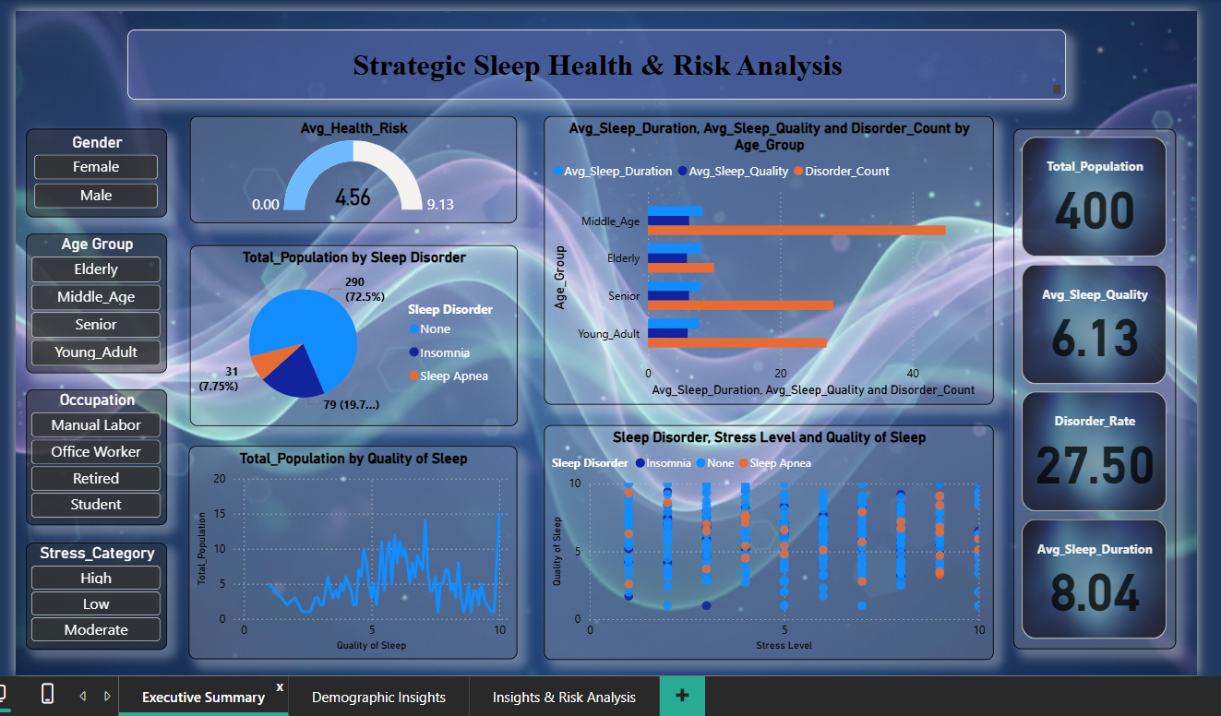

This page establishes the "big picture" and immediately identifies the dashboard's main story.
- Key Performance Indicators (KPIs): The top-line metrics reveal a significant health challenge:
  - Disorder Rate: 27.5% of the population (110 individuals) has a diagnosed sleep disorder.
  - Average Sleep Quality: The population-wide average is a mediocre 6.13 out of 10.
  - Average Sleep Duration: The average is 8.04 hours, indicating that time in bed is not the primary issue; quality of sleep is.
- Core Finding 1: Stress is the Primary Driver The central visual, "Sleep Disorder, Stress Level and Quality of Sleep," is the dashboard's most critical chart. It proves that poor sleep is not random but is strongly correlated with stress.
  - Analysis: As Stress Level (X-axis) increases, Quality of Sleep (Y-axis) plummets. The plot is color-coded by disorder: "Healthy" (dark blue) dots are clustered in the low-stress (1-5) range. As stress increases past 5, the chart becomes dominated by "Insomnia" (orange) and "Sleep Apnea" (light blue) dots.
  - Conclusion: This visual confirms a strong negative correlation (approx. -0.74), identifying high stress as the single most powerful predictor of poor sleep.
- Core Finding 2: Age-Based Risk The "Avg_Sleep_Duration, Avg_Sleep_Quality and Disorder_Count by Age_Group" chart reveals complex, age-based patterns.
  - Analysis: The "Senior" group has the highest "Disorder_Count" and "Avg_Sleep_Duration." Conversely, the "Young_Adult" group has the highest "Avg_Sleep_Quality" but the lowest "Avg_Sleep_Duration."
  - Conclusion: This suggests the nature of the disorder changes with age. Seniors may suffer from fragmented, low-quality sleep despite long duration, while Young Adults have more efficient, high-quality sleep in a shorter time window.
  - Page 2: Demographic Insights – The "Who & Why"
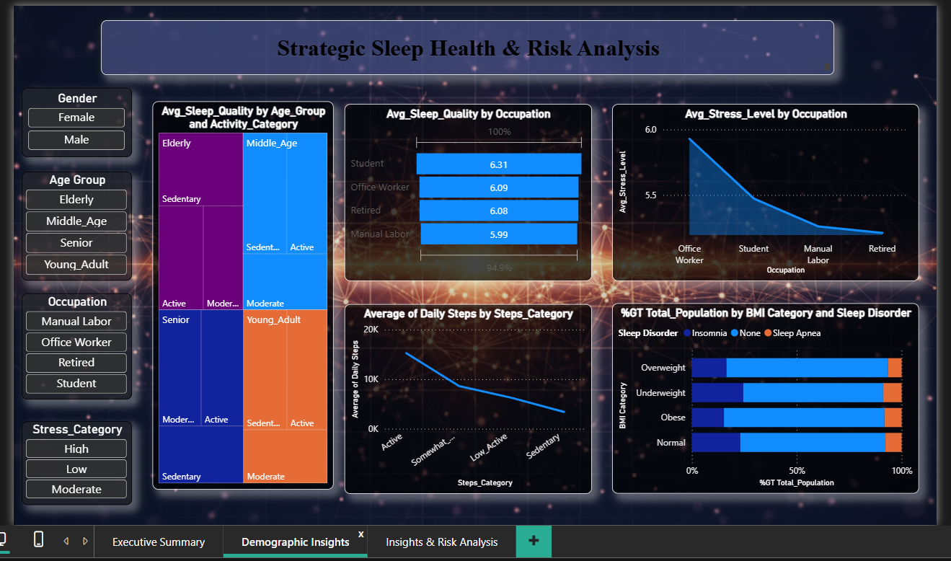

This page segments the population to understand the specific lifestyle and professional factors that contribute to risk.
- Core Finding 1: Occupational & Latent Risk This is a critical, multi-chart insight.
  - Analysis: The "Avg_Stress_Level by Occupation" line chart shows "Office Workers" and "Students" are the most-stressed groups (peaking at ~5.9). However, the "Avg_Sleep_Quality by Occupation" bar chart shows their sleep quality (6.09 - 6.31) is average and not the worst.
  - Conclusion: This exposes a hidden or latent risk. While high-stress "Office Workers" maintain average reported sleep quality for now, Page 3's ML model identifies them as a primary risk group. Their high stress makes them vulnerable, even if they haven't yet crossed the threshold into a full-blown disorder.
- Core Finding 2: The BMI-Apnea Link The "%GT Total_Population by BMI Category and Sleep Disorder" chart provides a clear, visual link between BMI and disorder type.
  - Analysis: The chart is a 100% stacked bar. The "Sleep Apnea" (light blue) band is visually 3-4x thicker for the "Obese" and "Overweight" populations compared to the "Normal" group.
  - Conclusion: This identifies high BMI as a primary co-morbidity and risk factor for Sleep Apnea, allowing for targeted intervention by the wellness team.

  - Page 3: Insights & Risk Analysis – The "Actionable Plan"
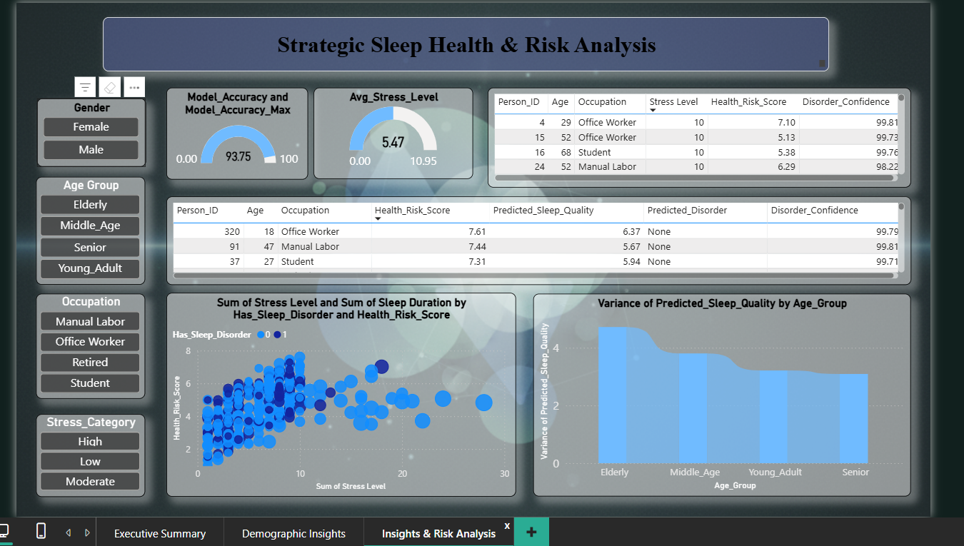

This is the payoff page. It uses the 93.75% accurate ML model to transform broad insights into an actionable priority list.
- Core Finding 1: Visualizing the Model's Logic The "Sum of Stress Level and Sum of Sleep Duration..." bubble chart plots Health_Risk_Score (Y-axis) against Stress Level (X-axis).
  - Analysis: The chart is a clear visual confirmation of the model's logic. The entire cluster of individuals who have a sleep disorder (Has_Sleep_Disorder = 1, light blue dots) is located almost exclusively in the high-stress, high-risk top-right quadrant.
  - Conclusion: This proves that stress is not just a "feeling"—it is a quantitative, predictive feature that directly maps to a high 'Health_Risk_Score'.
- Core Finding 2: The Actionable Priority List The two tables ("Person_ID, Age, Occupation...") are the dashboard's "call to action."
  - Analysis: When sorted by risk, a clear and alarming pattern emerges. Individuals (e.g., Person IDs 4, 15, 16, 24, 52, 68) who report a Stress Level of 10 are consistently flagged with the highest Health_Risk_Scores (e.g., 7.10, 5.38, 6.29) and an extremely high Disorder_Confidence (over 98-99% in all cases).
  - Conclusion: This is no longer just analysis; it is a ranked priority list for intervention. The model is flagging these specific individuals as being in a state of health crisis.

- Strategic Recommendations

This dashboard analysis delivers a clear, three-part strategic conclusion:
- RECOMMENDATION 1: PIVOT WELLNESS PROGRAMS TO STRESS MANAGEMENT. The data is conclusive: high stress is the root cause of poor sleep health in this population. Wellness initiatives must pivot from a general "sleep hygiene" message to a targeted stress-management program, especially for the "Office Worker" demographic.
- RECOMMENDATION 2: IMPLEMENT TARGETED INTERVENTIONS. A one-size-fits-all approach will fail. Interventions must be targeted at the key high-risk demographics identified in this analysis:
  - By Occupation: "Office Workers" (due to high latent stress).
  - By Physical Health: "Obese" & "Overweight" individuals (due to high Sleep Apnea risk).
  - By Lifestyle: "Sedentary" individuals (as "Active" is a proven mitigator across all ages).

4. Deep-Dive Analytical Q&A

- Q: 'Office Workers' are the most-stressed, so why isn't their sleep quality the worst?
  - A: This is a latent risk. Their high mental stress (seen on Page 2) makes them a top risk group, which the ML model (Page 3) confirms. They are likely "coping" for now, but are vulnerable.
- Q: 'Seniors' have the longest sleep duration on Page 1. Why are they a high-risk group?
  - A: Page 3 shows 'Elderly' have the highest variance in sleep quality. This means their long duration is likely low-quality, fragmented sleep, which is a key disorder symptom.
- Q: Why have both a 'Health_Risk_Score' and a 'Disorder_Confidence' on Page 3?
  - A: 'Disorder_Confidence' is diagnostic (99% chance you have it now). 'Health_Risk_Score' is prognostic (holistic risk of developing it). One is for treatment, the other is for prevention.
- Q: What is the single most actionable pattern in the "High-Risk" tables on Page 3?
  - A: A Stress Level of 10 is a direct "red flag." Nearly every high-risk individual reports this. It's the clearest indicator for immediate intervention.
- Q: The 'Total_Population by Quality of Sleep' line chart (Page 1) is chaotic. What's the insight?
  - A: The "chaos" shows the population is polarized, not a smooth bell curve. There is a healthy group (8-10) and a struggling group (1-4). Our job is to find and help the struggling group.
- Q: 'Elderly' has the highest sleep quality variance on Page 3. How do we act on that?
  - A: High variance means a "one-size-fits-all" program for seniors will fail. It proves intervention must be personalized based on the individual risk scores in the tables, not just their age.
- Q: What is the business implication of the bubble chart on Page 3 (Risk vs. Stress)?
  - A: It proves stress is a direct, quantitative cost. The chart visually maps high stress (a feeling) to a high 'Health_Risk_Score' (a cost). It provides the ROI argument for investing in stress-reduction programs.
- Q: The 'Gender' slicer doesn't seem to change the charts much. Is it useless?
  - A: No, that's a key finding. It proves the main drivers (Stress, BMI, Activity) are universal and affect both genders. This means our core wellness programs can be universal, not split by gender.
- Q: How do the 'Avg_Health_Risk' gauge (4.56) and 'Avg_Stress_Level' gauge (5.47) relate?
  - A: This is an optimistic finding. It shows the primary input (Stress) is higher than the final output (Risk). This means, on average, the population's mitigating factors (like physical activity) are successfully reducing their total health risk.
- Q: If you had to provide one single finding from the entire 3-page dashboard, what would it be?
  - A: The entire analysis ladders up to one finding: Poor sleep health is not a single issue; it is a symptom of a high-stress, low-activity, high-BMI lifestyle. The dashboard proves this by (1) identifying Stress as the #1 driver, (2) segmenting risk by Occupation and BMI, and (3) using an ML model to confirm that these factors can predict, with 93.75% accuracy, who is at risk.

